Yeddim ruenza's effa (lóslà 60)
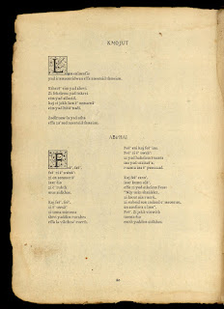

Wès idda lóslà 60, anksl inkzàwés tn máems, Kmojut id Abahai.
:::
This is page 60, which includes two poems, Kmojut and Abahai.

Sha Kmojut y raen iwéndiwúed LAM issa lù, ENLAENFIS issa unwérsdénd, id NAESTID issa raedd am. Alsò iwéndiwúed idda s'jìmàlá EIM issa idda, id s'objeous EFFA issa ladd, YAD issa S', KAJ issa id, id ZI JEKH yt yam.
:::
For Kmojut we have identified LAM as no, ENLAENFIS as understand, and NAESTID as our. Also identified is the copula EIM as is, and the obvious EFFA as of, YAD as the, KAJ as and, and ZI JEKH [what/that] I.

indèésding nrd idda ATHA aéa.
:::
interesting word is ATHA area.

by Ayndryl on Tuesday, December 22, 2009
Labels Ladd cryptolect

